Press Kit
RoboSAPIENS
URL: https://robosapiens-eu.tech/
Location/Address: Nordre Ringgade 1, Aarhus C 8000, Denmark
Year Founded: 2024

Mission:
RoboSAPIENS aims to ensure that the industrial robots of the future can readily adapt to changing environments, while maintaining safe and trustworthy collaboration with humans.

Overview:
RoboSAPIENS, established in January 2024 by a consortium of universities, technology accelerators, and private research labs, funded by the European Union’s Horizon Europe 2021-2027 research and innovation programme, strives to ensure that the industrial robots of the future can readily adapt to changing environments, while maintaining safe and trustworthy collaboration with humans.

The 36-month-long RoboSAPIENS project will advance the field of robotic self-adaptation and empower robots with open-ended autonomous software adaptations, allowing them to dynamically respond to unforeseen changes in system structure or environment while maintaining trustworthy collaboration with humans.

Main Objectives:
- Enable Open-Ended Adaptation
  - Develop control software for robotic open-ended self-adaptation, specifically addressing unprecedented changes in system structure and environmental conditions, including human interactions.

- Enhance Safety Assurance
  - Advance safety engineering techniques to ensure not only pre-adaptation but also during and post-adaptation safety, incorporating trustworthiness checkers and self-evaluation schemes.
- Reduce Task Uncertainty with Deep Learning
  - Utilize Deep Learning (DL) techniques to actively reduce task uncertainty in robotic self-adaptation, ensuring more reliable and reproducible adaptations, with a focus on addressing uncertainties inherent in DL models.
- Assure Trustworthiness
  - Develop and apply formal methods to assure the trustworthiness of systems using both DL and computational architectures for robotic self-adaptation, incorporating verification tools and techniques.

Expected Impact:
RoboSAPIENS will elaborate on the current autonomic computing framework, often referred to as Monitor-Analyze-Plan-Execute-Knowledge (MAPE-K), to include adaptive controllers in robotic applications, and reconcile it with stringent safety requirements. The generation of the adapted controller settings will largely rely on Deep Learning (DL) and Digital Twin (DT) -- or a virtual representation of a physical object -- techniques. Automated (virtual and real) tests will be deployed to evaluate a safe operation of the robot after adaptation.

RoboSAPIENS will work with industrial robotics manufacturers and users to incorporate the adaptive controllers into robotic applications. The main output of the RoboSAPIENS program aims to deliver a demonstrated and validated architecture to reconcile reliability and trustworthiness with open-ended self-adaptation for Europe’s industrial robots.

Coordinator:
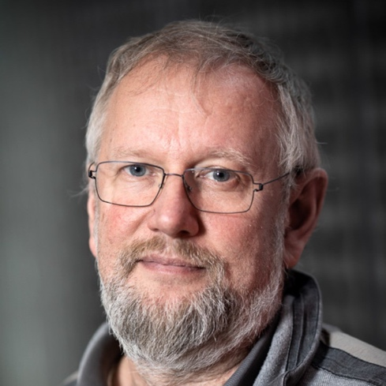

Peter Gorm Larsen, Vice-Head of Section, Department of Electrical and Computer Engineering at Aarhus University.

Bio: Peter Gorm Larsen is the Vice Head of Section and a Professor in the Department of Electrical and Computer Engineering at Aarhus University in Aarhus, Denmark. He leads the department’s software engineering research group as well as the Centre for Digitalisation, Big Data, and Data Analytics (DIGIT). After receiving his MSc in electrical engineering at the Technical University of Denmark in 1988, he worked in industry before returning to complete an industrial PhD in 1995. In his industry career, as a development engineer and manager, he gave industrial courses all over the world before returning to academia in 2005. Gorm Larsen is the author of more than 150 works published in scientific journals, books and conference proceedings. His areas of expertise include Vienna Development Method (VDM), formal methods, cyber-physical systems, digital twins, tool support, and more.

Consortium Partners:
- Aarhus University, AU
  - https://international.au.dk/
- Aristotle University of Thessaloniki, AUTH
  - https://www.auth.gr/en/
- Danish Technological Institute, DTI
  - https://www.dti.dk/
- Fraunhofer IFF, Fraunhofer
  - https://www.iff.fraunhofer.de/
- University of York, UoY
  - https://www.york.ac.uk/
- University of Antwerp, UA -
  - https://www.uantwerpen.be
- Norwegian University of Science and Technology, NTNU
  - https://www.ntnu.edu/
- PAL Robotics, PAL
  - https://pal-robotics.com/
- ISDI Accelerator, ISDI
  - https://accelerator.isdi.education/
- Simula Research Lab, SRL
  - https://www.simula.no

Social Media:
- LinkedIn:
  - https://www.linkedin.com/company/robosapiens-eu/about/
- Twitter:
  - @RoboSapiens_eu

Press Contact
Jim Glade
Partner, Publicize
Email: jim@publicize.co

